What if questions:

1. Count of 6 vs completion time

822 min

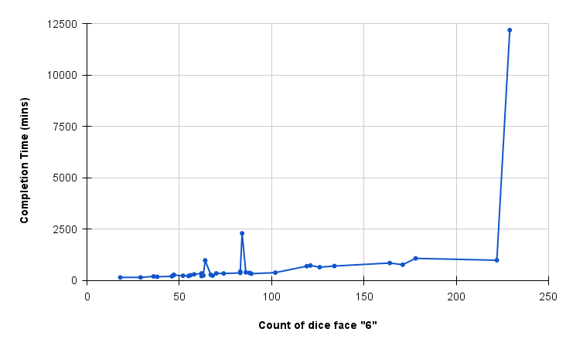

1. Count of 6 vs winner rate

1. Count of killed vs completion time

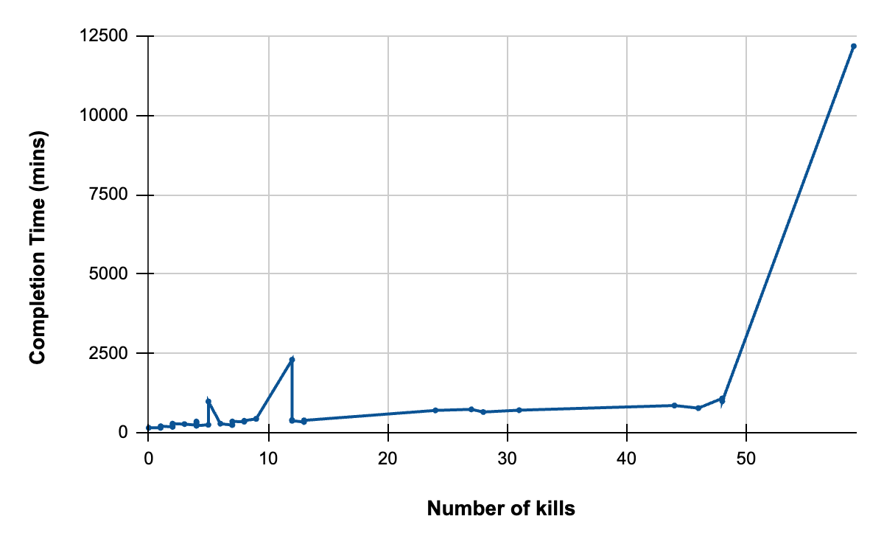

1. Count of killed vs winner rate

